**INDIVIDUAL ASSIGNMENT FOR WEEK 4**

**Question 1.**

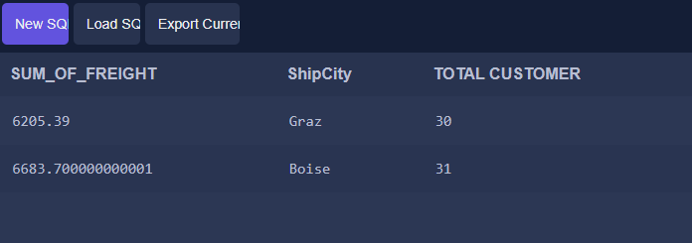

SELECT SUM(Freight) AS SUM_OF_FREIGHT, ShipCity,  
COUNT(CustomerId) AS 'TOTAL CUSTOMER' FROM 'Order' AS O JOIN Customer AS C ON C.Id = O.CustomerId  
GROUP BY CustomerId  HAVING count(CustomerId) >= 30;

**Question 2.**

SELECT EmployeeId, COUNT(DISTINCT(CustomerId)) AS No_Customers FROM 'Order'  
GROUP BY EmployeeId;

**Question 3.**

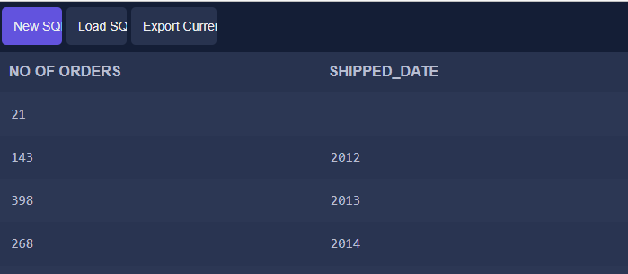

SELECT COUNT(Id) AS 'NO OF ORDERS',  
STRFTIME('%Y', ShippedDate) AS 'SHIPPED_DATE'  
FROM 'Order'  
GROUP BY  
STRFTIME('%Y', ShippedDate);

**Question 4.**



SELECT SUM(OrderDetail.Quantity) AS Quantity_of_Products, Product.ProductName, 'Order'.ShippedDate  
FROM OrderDetail  
INNER JOIN Product ON OrderDetail.ProductId = Product.Id  
INNER JOIN 'Order' ON 'Order'.Id=OrderDetail.OrderId  
WHERE ProductName='Chang' AND STRFTIME('%Y', ShippedDate) = '2014';

**Question 5.**

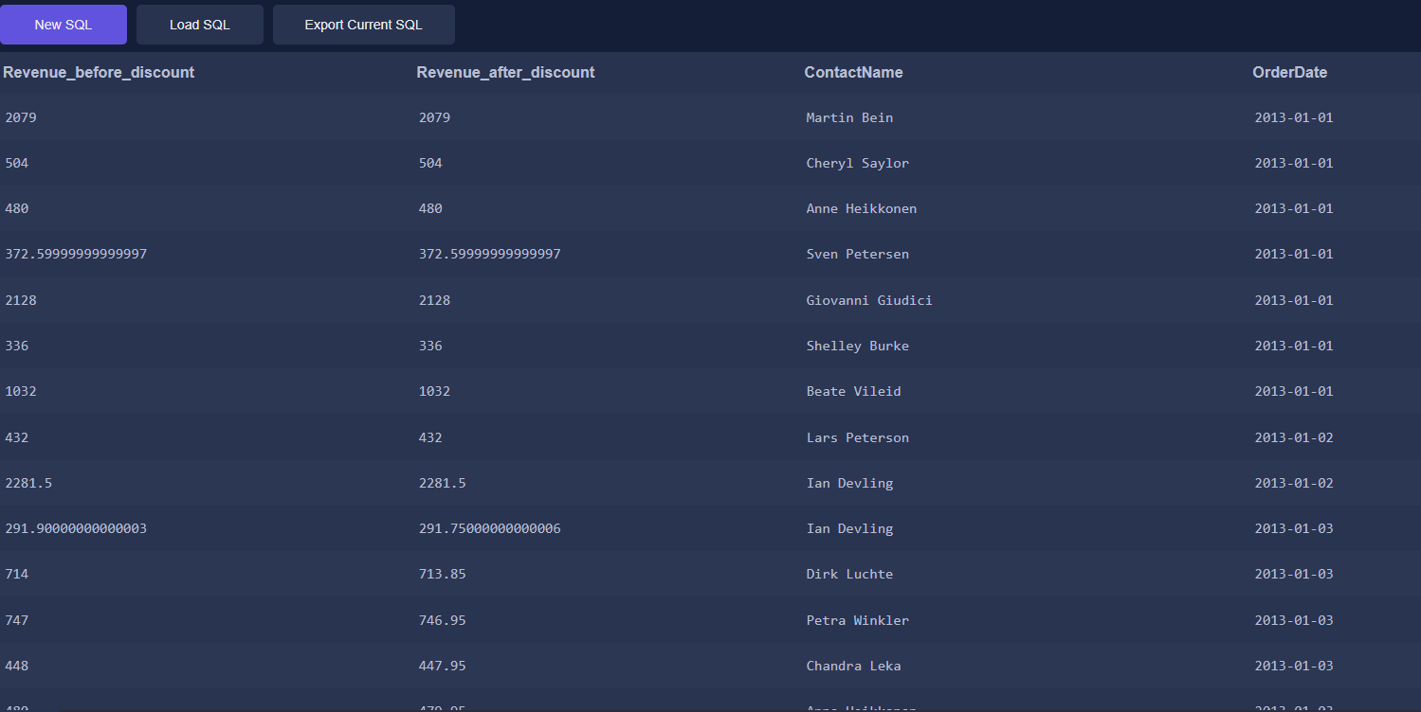

SELECT (OrderDetail.UnitPrice * OrderDetail.Quantity) As Revenu_before_discount,

(OrderDetail.UnitPrice * OrderDetail.Quantity)-(OrderDetail.Discount) AS Revenu_after_discount,

Supplier.ContactName, 'Order'.OrderDate

FROM OrderDetail

INNER JOIN 'Order' ON OrderDetail.OrderId='Order'.Id

INNER JOIN Product ON OrderDetail.ProductId = Product.Id

INNER JOIN Supplier ON Product.SupplierId= Supplier.Id

WHERE STRFTIME('%Y', OrderDate)='2013';